**Statement of the Originality**

This material contained in this document and any material or information disclosed during discussion of the proposal represents the proprietary, confidential information pertaining to web developing services, android developing services, methodologies and methods. Other products and brand names may be trademarks or registered trademarks of respective owner.

……………………………………………………………………………………………

**Professor Dr. Mohammed Humayun Kabir**

**(Supervisor)**

**Chairman**

**Department of CSTE, NSTU**

**Date:………………………………**

……………………………………………………

Md. Likhon Mia

(Candidate)

ID: ASH1401008M

Session: 2013-2014

Date:…………………………

**BOARD OF EXAMINES**

1. …………………………………………………..

Dr. Mohammed Humayun Kabir **chairman**

Professor

Department of CSTE, Noakhali Science and Technology University

2. …………………………………………………..

………………………………………………………………………………… **1stExamine**

…………………………………………………………………………………

Department of CSTE, Noakhali Science and Technology University

3. …………………………………………………..

……………………………………………………………………………… **2ndExamine**

………………………………………………………………………………

Department of CSTE, Noakhali Science and Technology University

4. …………………………………………………..

……………………………………………………………………………… **3rdExamine**

………………………………………………………………………………

Department of CSTE, Noakhali Science and Technology University

**Project Name**

**Quiz on Computer Hardware and Software Info.**

**ACKNOWLEDGEMENT**

Initially, we would like to express our gratitude towards the almighty Allah and gratefulness to our respected teacher and supervisor **Professor** **Dr. Mohammed Humayun Kabir**, **Chairman, Department of CSTE, NSTU** for providing us with all sorts of knowledge and support essential for carrying out this project and enabled us to present this dissertation in this form.

Department of Computer Science & Telecommunication Engineering also must come in special mention for the cooperation in completion of this research .We would like to give heartily thanks to our friends who provided a great help and co-operation for the existence of this output. Our obligation goes to our family and all our friends who assisted me directly and indirectly in completing this study. Lastly, I would like to extend my sincere gratitude to the known and unknown writers of the resources and publications that has been taken during the preparation of this project work.

**ABSTRACT**

Modern hand held devices such as smart phones have become increasingly powerful in recent years. However, there are some applications that allow users to flexibly execute tasks which are done by personal computer (PC), laptop etc. As mobile devices become more like PCs they will come to replace objects to accomplish necessary tasks. If any mobile applications has developed to mitigate administrative work as well as fulfil user (other than administrator) requirement, then task can be complete within the smart phone. Quiz on Computer Hardware and Software Info application, which is developed for Android base platform falls into this category.

This project is aimed at developing an android application that can show some most important information about computer hardware and software as well as users will be capable of examine their knowledge about hardware and software by answering various types of quizzes.

This android application is a virtual system where all types of students can gather knowledge about the computer hardware and software and can attend the quiz part.

Though this application is helpful for those students who want to know important information about the computer hardware and software, it’s not dynamic. But in this application the quiz part is random.

The prototype was developed using XML, JAVA and SQLite Database.

**Table of Contents**

**Chap-1. Introduction**

* 1. Introduction
     1. What is Android?
     2. What is SQLite Database?
     3. Features of Quiz on computer hardware and software info.
  2. Objectives
  3. Problem Statement

1.3.1. Existing System

1.3.2. Proposed System

**Chap-2. Methodology**

2.1. Definition of Methodology

2.1.1. Methodology of the system

2.2. Tools Requirement

2.3. Feasibility Study

2.3.1. Economic Feasibility

2.3.2. Technical Feasibility

2.3.3. Operational Feasibility

2.4. Software Engineering Paradigms Applied

**Chap-3. Working procedure visualization**

3.1. Overall view of server

3.2. Working procedure

3.2.1. Works of computer hardware and software info button

3.2.2. Works of quiz button

3.3. About us, share and feedback

3.4. Configuration

3.4.1. Hardware Configuration

3.4.2. Software Configuration

**Chap-4. System Design & Implementation**

4.1. System Design

4.2. Design Methodology

4.2.1. Logical Design

4.2.2. Physical Design

4.2.3. Modular Design

4.3. Database Design

4.3.1. E-R Diagram

4.3.2 Dataflow Diagram

4.3.3. Database Tables

**Chap-5. Software requirements**

5.1. Front End

5.1.1. XML

5.2. Back End

5.2.1. Java

5.2.2. SQLite Database

**Chap-6. Conclusion**

6.1. Conclusion

6.2. Future Prospects

**Chap-7. Appendix**

7.1. Project Screenshots at a glance

7.2. References

**Overview**

* **Introduction**
* **What is Android?**
* **What is SQLite Database**
* **Features of Quiz on computer hardware and software info.**
* **Objective**
* **Problem Statement**
* **Existing System**
* **Proposed System**

**Overview:**

In this I will try to give a short introduction about my project. I also focus on existing system and proposed system. In the last section, I will discuss about my whole project.

* 1. **Introduction**

The motive of this project is to show all the information about computer hardware and software and improve the knowledge skill by taking the quiz test. This android application helps the students to increase their knowledge. This application has also helped us to know about two terms.

1. Android
2. SQLite Database

**1.1.1. What is Android?**

Android is a mobile operating system developed by Google, based on a modified version of the Linux kernel and other open source software and designed primarily for touchscreen mobile devices such as smartphones and tablets. In addition, Google has further developed Android TV for televisions, Android Auto for cars, and Wear OS for wrist watches, each with a specialized user interface. Variants of Android are also used on game consoles, digital cameras, PCs and other electronics.

**1.1.2. What is SQLite Database?**

**SQLite** is a programming library which implements a relational database management system. The SQLite database concept is, in contrast to other client-server systems, to be linked into the applications code, instead of providing a standalone daemon with which an application can communicate to request or write data. Because of the small size of the library itself, and the ease of use, it is especially interesting for [embedded systems](http://en.wikipedia.org/wiki/embedded_systems). SQLite supports a variety of SQL- (**S**tructured **Q**uery **L**anguage) commands with some exceptions and does not provide any access or user-management. That means, that everyone, who can access the database file, can access the data as well as write (change, delete, add) data, if he can write the database file. It therefore inherits the access permissions of the file system.

**1.1.3. Features of Quiz on computer hardware and software info.**

* Admin login page
* Student login page
* Student registration page
* Admin homepage
* Quiz page
* Quiz result page
  1. **Objectives**
* The main objective to create this Quiz on computer hardware and software info app is to help the users for the preparation of necessary educational purposes regarding Computer Science and IT field with an easy access to our app directly on their Android phones.
* Through our app, users can learn and prepare themselves for interviews, tests and exams on Android phones.
* User can also use this app for increasing their general knowledge about Computer Science, Verbal and Analytical everywhere and anytime.
  1. **Problem Statement**
* Since the traditional system have many drawbacks such as we can’t learn computer hardware and software information at a time in one place.
* Collection of data is very deficient.
* Time consuming.
  + 1. **Existing System**
* Earlier students learn about computer hardware information from different online resource and books.
* It is very time consuming process.
* Earlier where students used to perform all tasks manually be it Student Registration, Setting Quiz Papers, Setting Schedules to finally declaring the result.
* It was cumbersome since these details were now generated, managed and kept in computers
  + 1. **Proposed System**

The proposed system which is very fast and efficient can be used conveniently as an alternative to the existing manual system. The aim are to handle the following:

* The Quiz on computer hardware and software info is a mobile based android application
* The system suits for student who are keen to learn and develop their knowledge about computer hardware
* This product (system) aims at reducing cost and time.
* It provides an easy access to the users.

**Overview**

* **Definition of Methodology**
* Methodology of the System
* **Tools Requirement**
* **Feasibility Study**
* Economic Feasibility
* Technical Feasibility
* Operational Feasibility

* **Software Engineering Paradigms Applied**

**Overview:** In this chapter, I will try to discuss about the methodology of my project. I will discuss about tools requirement and feasibility studies of my project here.

**2.1. Definition of Methodology**

**Methodology** is a system of broad principles or rules from which specific methods or rules procedures may be derived to interpret or solve different problems within the scope of a particular discipline. Unlike an algorithm, a methodology is not a formula but a set of practices. Methodology is the analysis of the principles or procedures of inquiry in a particular field. It is the procedure where the system of methods and principles used in a particular discipline. Software process is the way in which we produce the software. Apart from hiring smart, knowledgeable engineers and buying the latest development tools, effective software development process is also needed, so that engineers can systematically use the best technical and managerial practices to successfully complete their projects. A software life cycle is the series of identifiable stages that a software product undergoes during its lifetime .A software lifecycle model is a descriptive and diagrammatic representation of the software life cycle .A life cycle model represents all the activities required to make a software product transit through its lifecycle phases .It also captures the order in which these activities are to be taken.

**2.1.1. Methodology of the System**

There are various life cycle models to improve the software processes:

* WATERFALL MODEL
* PROTOTYPE MODEL
* ITERATIVE ENHANCEMENT MODEL
* EVOLUTIONARY MODEL
* SPIRAL MODEL

In order to develop the Online Voting System we considered to use a development methodology and it is the waterfall model. Methodology is used during the development of an IT project; it describes the different stages involved in the project from the drawing board, through the completion of the project. A series of steps followed by the developer are**:**

* **Requirement gathering and analysis**: First we need to study Java, XML and SQLite Database to make this project well developed and dynamic. Then need to collect information available in online or manual for developing project. After requirement gathering these requirements are analyzed for their validity and the possibility of incorporating the requirements in the system to be development is also studied.
* **Design:** In this phase the system and software design is prepared from the requirement specifications which were studied in the first phase. System Design helps in specifying hardware and system requirements and also helps in defining overall system architecture. The system design specifications serve as input for the next phase of the model.
* **Implementation / Coding:** On receiving system design documents, the work is divided in modules/units and actual coding is started. Since, in this phase the code is produced so it is the main focus for the developer. This is the longest phase of the software development life cycle.
* [**Testing**](http://istqbexamcertification.com/what-is-a-software-testing/)**:**  After the code is developed it is tested against the requirements to make sure that the product is actually solving the needs addressed and gathered during the requirements phase. During this phase unit testing, integration testing, system testing, acceptance testing are done.
* **Deployment:** After successful testing the product is delivered / deployed to the students/candidates for their use.
* **Maintenance:** Once when the students/candidates start using the developed system then the actual problems comes up and needs to be solved from time to time. This process where the care is taken for the developed product is known as maintenance

**Waterfall model:**

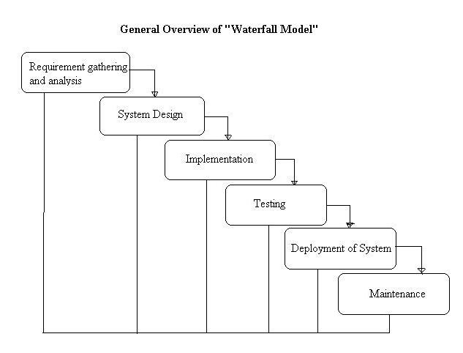

**Fig: Water fall model approach**

**Why we are using this model:**

* My requirements are clear, well known and fixed.
* Technology is understood.
* Project is short.
* Product definition is stable.
* There are no ambiguous requirements.

**2.2. Tools Requirement**

* Programming Language : Java, XML
* Waterfall Model
* IDE : Android studio
* Emulators: Android Virtual Device ( AVD )
* Tools used: SDK Tools, Android platform Tools, Android Developer Tools.

**2.3. Feasibility Study**

Feasibility study includes consideration of all the possible ways to provide a solution to the given problem. The proposed solution should satisfy all the user requirements and should be flexible enough so that future changes can be easily done based on the future upcoming requirements.

**2.3.1. Economic Feasibility**

Economic analysis is most frequently used for evaluation of the effectiveness of the system. More commonly it is known as cost/benefit analysis the procedure is to determine the benefit and saving that are expected from a system and compared them with costs, decisions is made to design and implement the system. This part of feasibility study gives the top management the economic justification for the new system. This is an important input to the management, because very often the top management does not like to get confounded by the various technicalities that bound to be associated with a project of this kind. A simple economic analysis that gives the actual comparison of costs and benefits is much more meaningful in such cases. It is economically feasible, it will only require a single operator to operate the system, who is responsible for entering the data into the database via a user interface provided to him, who can also able to show all the data in html tabular form so to provide information regarding the students who are either taken admission or to take admission, since it requires only a single person to operate the whole system thus reduces the cost to operate the system.

In the system, the organization is most satisfied by economic feasibility. Because, if the organization implements this system, it need not require any additional hardware resources as well as it will be saving lot of time.

**2.3.2. Technical Feasibility**

Technical feasibility centers on the existing manual system of the test management process and to what extent it can support the system. According to feasibility analysis procedure the technical feasibility of the system is analyzed and the technical requirements such as software facilities, procedure, inputs are identified. It is also one of the important phases of the system development activities. It is technically feasible, since the whole system is designed into the latest technologies like JSP, Servlet and MYSQL Server which are the most recent technologies to develop web based systems and design databases. The system offers greater levels of user friendliness combined with greater processing speed. Therefore, the cost of maintenance can be reduced. Since, processing speed is very high and the work is reduced in the maintenance point of view management convince that the project is operationally feasible. The system have been developed using JSP and Servlet, the project is technically feasible for development.

**2.3.3. Operational Feasibility**

It is Operational feasible, since the system is providing an attractive user interface to the operator/end user, so he feel very easy to work onto it. Response to operator/end user is very fast and very good. Since, as we mentioned above that it requires much less amount of cost, it uses computer work so it is very fast to operate and it is very easy for user to work on it. The operational feasibility is the one that will be used effectively after it has been developed. It is easy to operate after implemented and we say this project is operationally feasible.

**2.4. Software Engineering Paradigms Applied**

The two main programming approaches are top-down approach and bottom-up approaches. Here while doing the software for online placement system; we use the bottom up approach. In bottom up method, the sub modules are designed and developed and these are assembled together to get the main system. The individual modules are coded and debugged with example data given checks ready for the major project design. The individual module transaction processing can be checked thoroughly so that minute mistakes and correction can be passed from one module to other when required and these requisition are also considered at the development stage of code module. These checked and corrected modules will be integrated to make the entire system. This project also followed the bottom up design. The sub modules are prepared very keenly and minute notations are made.

**Overview**

* **Overall view of server**
* **Working procedure**
* Works of computer hardware and software button
* Works of quiz button
* **About us, Share and Feedback**
* **Configuration**
* Hardware Configuration
* Software Configuration

**Overview:** In this chapter, I will discuss about requirement specification of my project. It also include some information about different equipment’s which is related to the project.

**3.1. Overall view of server**

The project work is about showing the hardware and software information to the students and influence them to attend the quiz test so that they can examine their knowledge. Development of android-based Quiz on computer hardware and software info application is mainly required by students and learners to prepare themselves for different examinations directly through smart phones and tablets in hands. In today’s world Smart phones have changed our lives and have become an indispensable part of our lives because of its specialty to simplify our routine work and thereby saving our time. Android based device like mobile, tab are very user friendly. In this context, Project application is developed based on android platform. By using this application, user can learn computer hardware elements information and develop their skill by using quiz system. So, goals of this project to facilitate users to give quizzes with this android based smart phone.

**3.2. Working procedure**

At first when the students press the application icon he/she will be able to see two portions those promote the overall view of the application.

**3.2.1. Works of computer hardware and software button**

By pressing **computer hardware and software info** button he/she can get various information about the hardware and software elements of the computing system like “Motherboard”, ”CPU”, ”RAM”, ”MEMORY”, ”HARD DRIVE”, “MOUSE”, ”PRINTER”, ”MODEM”, ”OPTICAL DRIVE” etc. He/she able to see some images those are related to the button which have been mentioned earlier.

**3.2.2. Works of quiz button**

By pressing **Quiz** buttonhe/she will be able to see two parts. One is **student panel** and another is **admin panel.**

The admin panel is useable only for admin. He/she can change, modify and insert any quiz related data into the database. Before that he/she needs to insert **admin name** and **password** for the verification purpose. He/she can’t get access to the database and overall system without the valid **admin name** and **password**.

If any unauthorized entity wants to get access to the system with wrong **admin name** and **password**, the system will allow him/her to have **3** attempts. After finishing his/her **3** attempts the **login** Button will be vanished and that unauthorized entity will not be able to get access to the system. That is how the privacy and confidentiality of the system of this application is kept and protected.

By pressing **student panel** Button the students will be able to get access the first step of the quiz test. After pressing the **student panel** button he/she have to insert their **name**, **password** and **Email id** for registration. If any student has already registered to the Quiz system he/she can be able to join the Quiz test by pressing the **login** button.

After pressing the **login** button he/she will see the **start quiz** button and after pressing so he/she will be able to answer the quiz questions. Each student is allowed **30** seconds to point the multiple choice and see the correct answer.

After pointing out every question any student can see the final score he/she has obtained. Pointing out every wrong answer will show the correct answer with green color.

**3.2.2. About us, Share and Feedback**

This also include some other options. Such as about us, Share, Feedback. By the **about us** info the user can get the details information about the developers as well as about the supervisor of the application. If the user wants to communicate with the developers and the supervisor then the user can get the Facebook id and Social account of the developers and the supervisor. Through those accounts the user can communicate with the developers and the supervisor

By the Share option one can share the news about the application and he/she can copy the data and can share those data in many social media sites.

By Feedback option one can put his/her opinion about the application and features he/she gets from the application. The opinion the user wants to put will go to E-mail address of the admin and the developers of the application. The feedback may be positive or negative. This option will increase the possibility of the enhancement of the application.

**3.4. Configuration**

This class describes all device configuration information that can impact the resources the application retrieves. This includes both user-specified configuration options (locale list and scaling) as well as device configurations (such as input modes, screen size and screen orientation).

**3.4.1. Hardware Configuration**

* System : Multimedia PC
* Processor : Dual Core or above
* Memory : 1GB RAM
* Hard Disk : 500GB or above
* Keyboard : 104 standards
* Monitor : SVGA
* Modem : Dial up/Broadband

**3.4.2. Software Configuration**

* Front End: XML.
* Back End: Java and SQLite database

**Overview**

* **System Design**
* **Design Methodology**
* **Logical Design**
* **Physical Design**
* **Modular Design**
* **Database Design**
* **E-R Diagram**
* **Data Flow Diagram**

**Overview:**

In this chapter, I will discuss about ER diagram and database tables of my project. And I’ll discuss about implementation of Program Code which is the basic part of my project. I also include some information about different equipment’s which is related to the diagram.

**4.1. System Design**

The system design develops the architectural detail required to build a system or product. As in the case of any systematic approach, this software too has undergone the best possible design phase fine tuning all efficiency, performance and accuracy levels. The first step in system designing is to determine how the output is to be produced and in what format. Samples of the output and input are also presented. In the second step, input data and master files are to be designed to meet requirement of the proposed output. The processing phases are handled through program construction and testing, including a list of the programs needed to meet the system’s objectives and complete documentation.

**4.2. Design Methodology**

System design is the solution to the creation of a new system. This phase is composed of several systems. This phase focuses on the detailed implementation of the feasible system. It emphasis on translating design specifications to performance specification. System design has two phases of development logical and physical design. During logical design phase the analyst describes inputs (sources), outputs (destinations), databases (data sores) and procedures (data flows) all in a format that meats the uses requirements. The analyst also specifies the user needs and at a level that virtually determines the information flow into and out of the system and the data resources. Here the logical design is done through data flow diagrams and database design. The physical design is followed by physical design or coding. Physical design produces the working system by defining the design specifications, which tell the programmers exactly what the candidate system must do. The programmers write the necessary programs that accept input from the user, perform necessary processing on accepted data through call and produce the required report on a hard copy or display it on the screen.

**4.2.1. Logical Design**

Logical design of an information system shows the major features and also how they are related to one another. The first step of the system design is to design logical design elements. This is the most creative and challenging phase and important too. Design of proposed system produces the details of the state how the system will meet the requirements identified during the system analysis that is, in the design phase we have to find how to solve the difficulties faced by the existing system. The logical design includes input design, output design, and database design and physical design.

**4.2.2. Physical Design**

The process of developing the program software is referred to as physical design. We have to design the process by identifying reports and the other outputs the system will produce. Coding the program for each module with its logic is performed in this step. Proper software specification is also done in this step.

**4.2.3. Modular Design**

A software system is always divided into several sub systems that makes it easier for the development. A software system that is structured into several subsystems makes it easy for the development and testing. The different subsystems are known as the modules and the process of dividing an entire system into subsystems is known as modularization or decomposition.

A system cannot be decomposed into several subsystems in any way. There must some logical barrier, which facilitates the separation of each module. The separation must be simple but yet must be effective so that the development is not affected.

The system under consideration has been divided into several modules taking inconsideration the above-mentioned criteria. The different modules are

* user module
* administrator module

**4.3. Database Design**

This part shows the Entity Relationship Diagram and database tables of the proposed system.

**4.3.1. E-R Diagram**

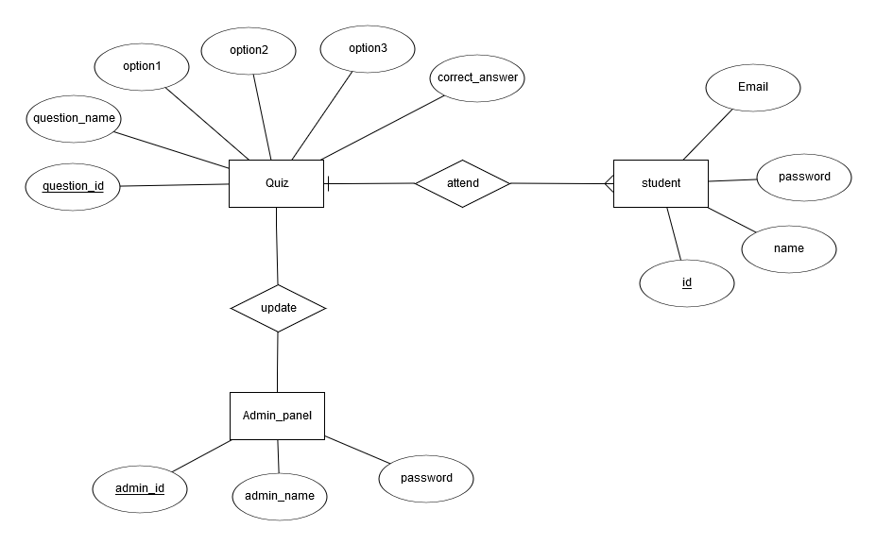

**4.3.2. Dataflow Diagram**

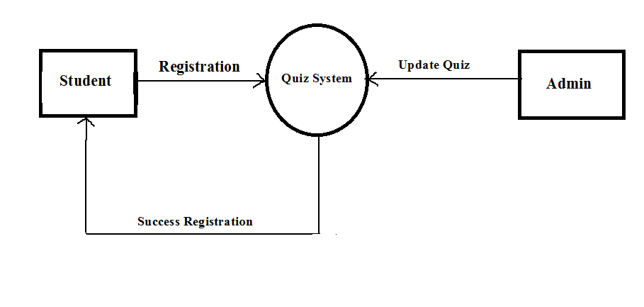

**Fig: Data flow Diagram**

**4.3.3. Database Tables**

**Table: Admin**

|  |  |  |
| --- | --- | --- |
| Admin_id(primary) | Admin_name | Admin_password |
| 30 | 100 | 100 |

**Table: Candidate**

|  |  |  |
| --- | --- | --- |
| Student_id(primary) | Student_email | Student_password |
| Int(30) | varchar(100) | varchar(100) |

**Overview**

* **Front End**
* **XML**
* **Back End**
* **Java**
* **SQLite Database**

**Overview:**

In this chapter, I will discuss about Front End and Back End of my project. And I’ll discuss about implementation of Program Code which is the basic part of my project. I also include some information about different equipment’s which is related to the application.

**5.1. Front End**

The front end is the visual part of the app that the user interacts with, and the back end, which contains all the code that drives the app.

The front end is written using XML. I have never used XML before, but it is very similar to HTML in that it is a mark-up language that uses nested tags as its programming structure. Android uses several XML files to create the app’s front end. There is at least one XML layout file for each activity (or several if you are supporting multiple device sizes), as well as layout files for custom views. XML is also used to define constant strings that will be placed in the layouts, such as the text on a button.

**5.1.1. XML**

**XML:** In [computing](https://en.wikipedia.org/wiki/Computing), **Extensible Mark-up Language** (**XML**) is a [mark-up language](https://en.wikipedia.org/wiki/Markup_language) that defines a set of rules for encoding [documents](https://en.wikipedia.org/wiki/Electronic_document) in a [format](https://en.wikipedia.org/wiki/File_format) that is both [human-readable](https://en.wikipedia.org/wiki/Human-readable_medium) and [machine-readable](https://en.wikipedia.org/wiki/Machine-readable_data). The [W3C](https://en.wikipedia.org/wiki/World_Wide_Web_Consortium)'s XML 1.0 Specificationand several other related specificationsall of them free [open standards](https://en.wikipedia.org/wiki/Open_standard)—define XML. The design goals of XML emphasize simplicity, generality, and usability across the [Internet](https://en.wikipedia.org/wiki/Internet). It is a textual data format with strong support via [Unicode](https://en.wikipedia.org/wiki/Unicode) for different [human languages](https://en.wikipedia.org/wiki/Language). Although the design of XML focuses on documents, the language is widely used for the representation of arbitrary [data structures](https://en.wikipedia.org/wiki/Data_structure) such as those used in [web services](https://en.wikipedia.org/wiki/Web_service).

**5.1. Back End**

An App Engine project which contains the backend application source. An endpoints module with a Register Activity class, related resources, and client libraries for the Android app to communicate with the backend.

**5.2.1. Java**

**Java: Java** is a general-purpose [computer-programming language](https://en.wikipedia.org/wiki/Programming_language) that is [concurrent](https://en.wikipedia.org/wiki/Concurrent_computing), [class-based](https://en.wikipedia.org/wiki/Class-based_programming), [object-oriented](https://en.wikipedia.org/wiki/Object-oriented_programming), and specifically designed to have as few implementation dependencies as possible. It is intended to let application developers "[write once, run anywhere](https://en.wikipedia.org/wiki/Write_once,_run_anywhere)" (WORA), meaning that [compiled](https://en.wikipedia.org/wiki/Compiler) Java code can run on all platforms that support Java without the need for recompilation. Java applications are typically compiled to [byte code](https://en.wikipedia.org/wiki/Java_bytecode) that can run on any [Java virtual machine](https://en.wikipedia.org/wiki/Java_virtual_machine) (JVM) regardless of [computer architecture](https://en.wikipedia.org/wiki/Computer_architecture).

**5.2.1. SQLite Database**

**SQLite Database: SQLite** is a programming library which implements a relational database management system. The SQLite database concept is, in contrast to other client-server systems, to be linked into the applications code, instead of providing a standalone daemon with which an application can communicate to request or write data. Because of the small size of the library itself, and the ease of use, it is especially interesting for [embedded systems](http://en.wikipedia.org/wiki/embedded_systems). SQLite supports a variety of SQL- (**S**tructured **Q**uery **L**anguage) commands with some exceptions and does not provide any access or user-management. That means, that everyone, who can access the database file, can access the data as well as write (change, delete, add) data, if he can write the database file. It therefore inherits the access permissions of the file system.

**Overview**

* **Conclusion**
* **Future prospects**

**Overview:**

In this chapter, I will try to draw a conclusion of my project. For this I will focus on Limitations and future work of this project.

**6.1. Conclusion**

The Computer Hardware and software info is developed using java and XML fully meets the objectives of the system for which it has been developed. The system has reached a steady state where all bugs have been eliminated. The system is operated at a high level of efficiency and all user associated with the system understands its advantage. The system solves the problem. It was intended to solve as requirement specification.

This application is a student friendly android application. We hope it will play a vital role in improving the student knowledge and also enhance the student’s capability to join any quiz test. It will be helpful to gather knowledge and analyze them in a proper scientific manner. Thus the students will get their valuable info according to the modern technology and use them in further future.

**6.2. Future prospects**

1. In future some new and more attractive features will be added.

**2.** In future more data will be added.

**3.** The system will be online by the use of domain and hosting in future.

**Overview**

* **References**

**Overview:**

In this Section, I will include some of References from where I was gathered all of this datas and information’s of this project work.

**7.1. Appendix**

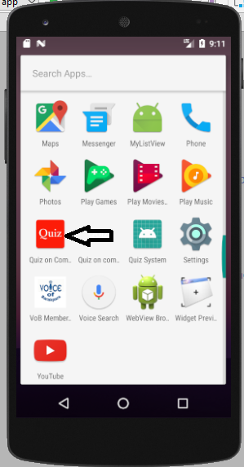 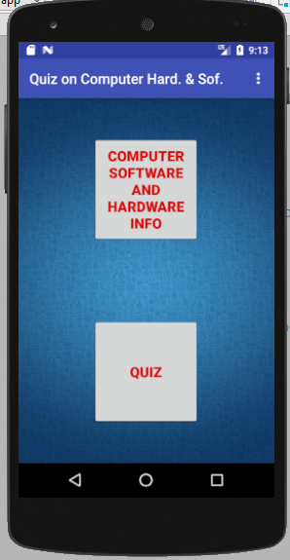

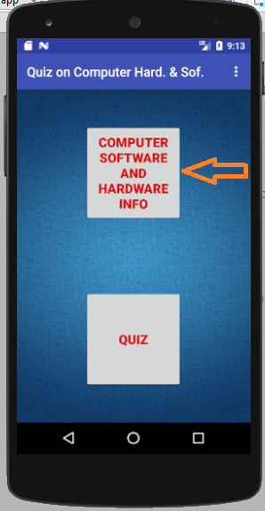 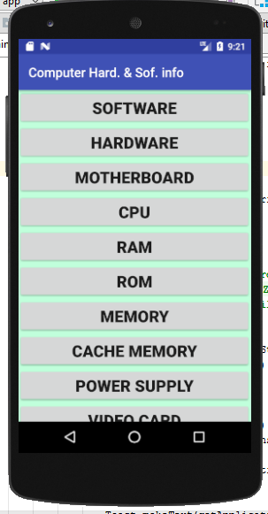

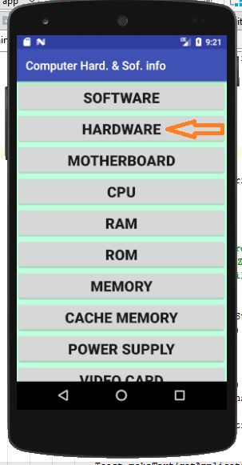 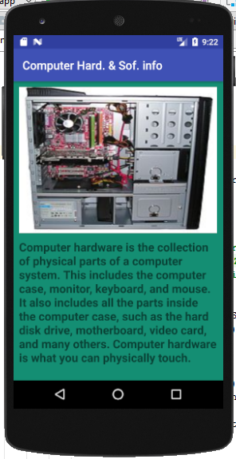

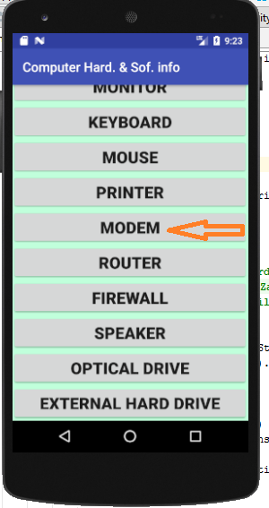 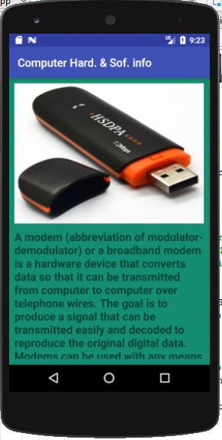

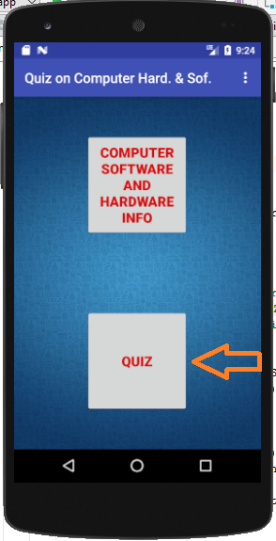 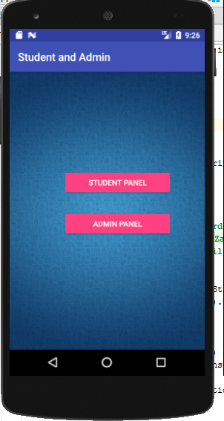

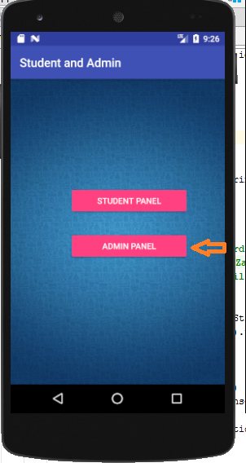 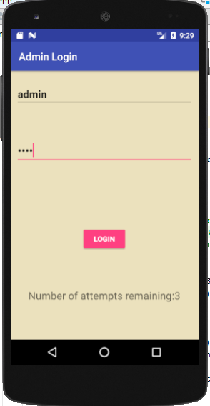

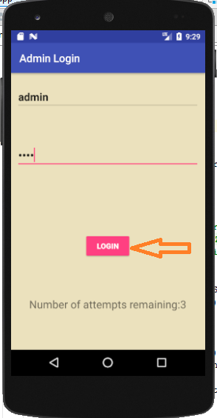 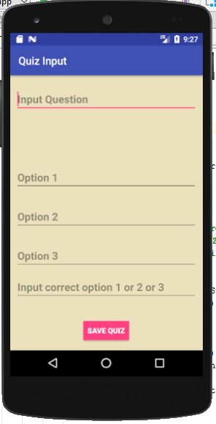

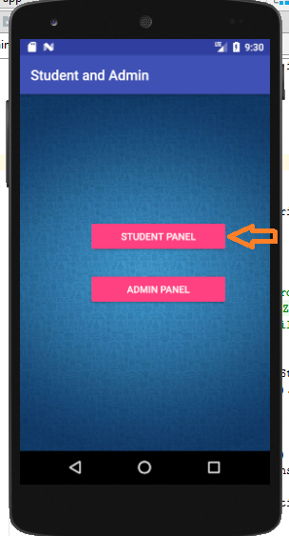 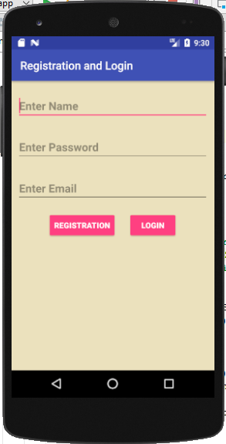

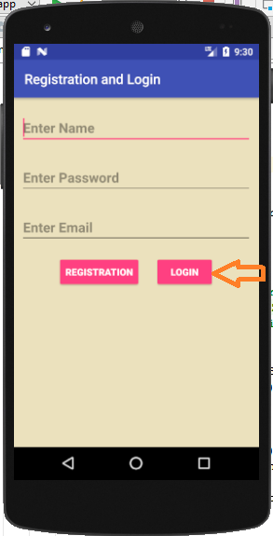 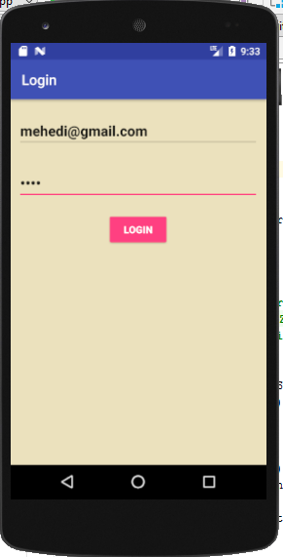

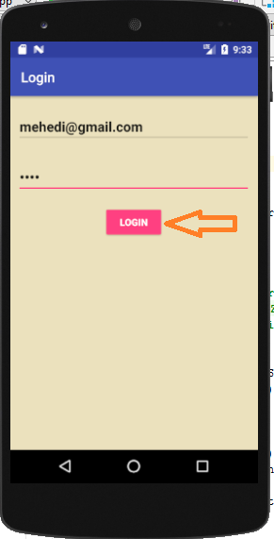 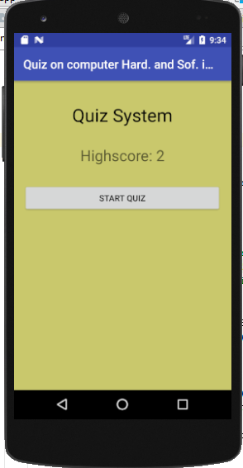

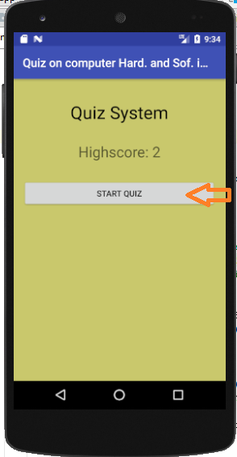 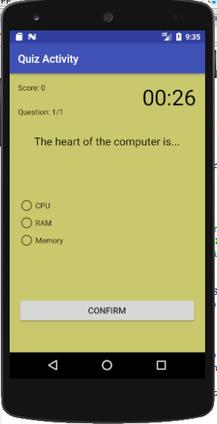

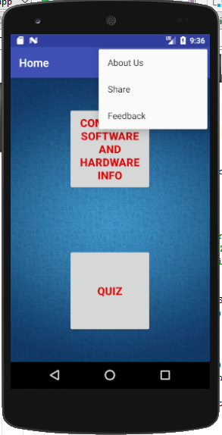

**7.2. References**

[1]. Details about Android https://developer.android.com/studio/

[2]. YouTube Link https://youtu.be/ZYvbmVEwX14

[3]. Details about XML https://youtu.be/IMaKFFzCVLE

[4]. Details about SQLite Database https://youtu.be/WRrB7WUj4zQ

[5]. Quiz part https://youtu.be/PiCZQg4mhBQ